Fundamentals Of Data Science
CSA-0412
Name : B.Ganga Niranjan
Reg No : 192424041
Date : 08/01/2026

- Student Performance Data

Code:
student_scores = pd.read_csv("/content/student_scores.csv").to_numpy()
avg_scores = np.mean(student_scores, axis=0)
subjects = ["Math", "Science", "English", "History"]

max_index = np.argmax(avg_scores)
print("Average scores per subject:", dict(zip(subjects, avg_scores)))
print("Subject with highest average score:", subjects[max_index], "with", avg_scores[max_index])

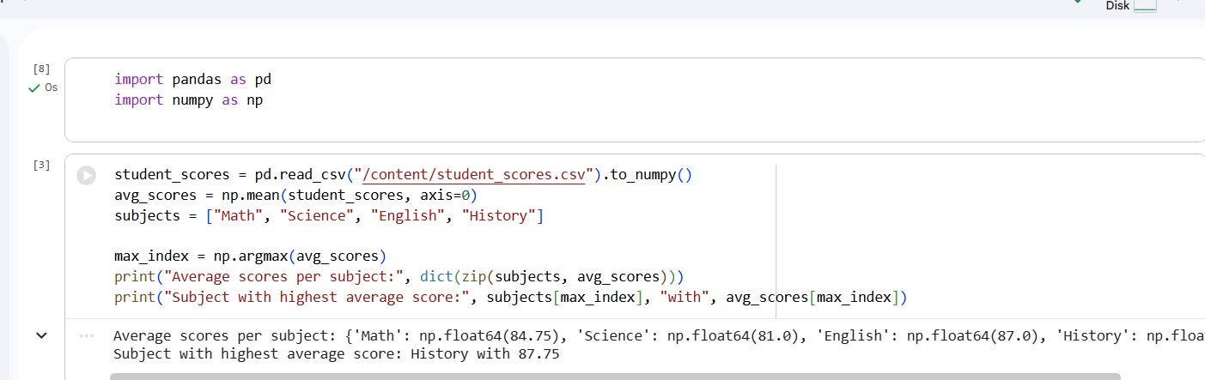
Output:

- Product Sales Data

Code:

product_sales = pd.read_csv("/content/product_sales.csv").to_numpy()
avg_price = np.mean(product_sales)
print("\nAverage price of all products sold:", avg_price)

Output:
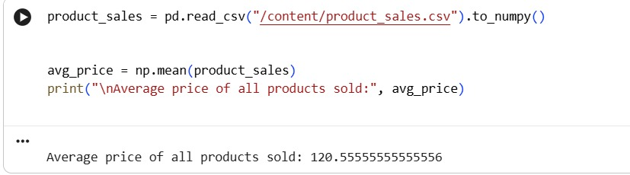

- House Data

Code:
house_data = pd.read_csv("/content/house_data.csv").to_numpy()
houses_5plus = house_data[house_data[:, 0] > 4]
avg_sale_price = np.mean(houses_5plus[:, 2])
print("\nAverage sale price of houses with more than 4 bedrooms:", avg_sale_price)

Output:
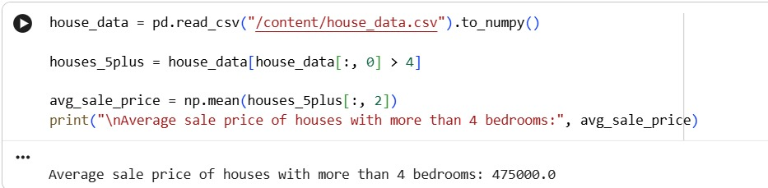

- Quarterly Sales Data

Code:

sales_data = pd.read_csv("/content/sales_data.csv").to_numpy().flatten()
total_sales = np.sum(sales_data)
percentage_increase = ((sales_data[3] - sales_data[0]) / sales_data[0]) * 100
print("\nTotal sales for the year:", total_sales)
print("Percentage increase from Q1 to Q4:", percentage_increase, "%")

Output:
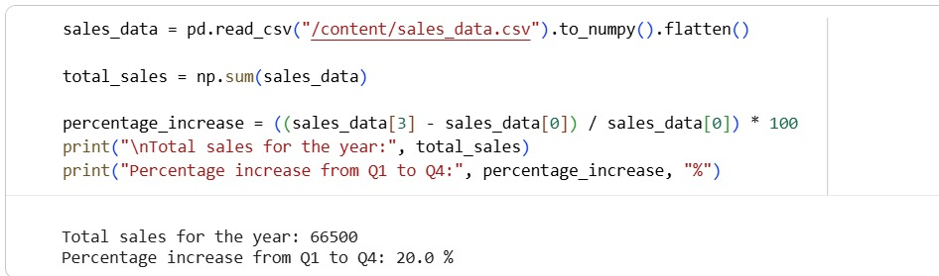

- Fuel Efficiency Data

Code:

fuel_efficiency = pd.read_csv("/content/fuel_efficiency.csv").to_numpy().flatten()
avg_efficiency = np.mean(fuel_efficiency)
percentage_improvement = ((fuel_efficiency[1] - fuel_efficiency[0]) / fuel_efficiency[0]) * 100
print("\nAverage fuel efficiency:", avg_efficiency)
print("Percentage improvement from car 1 to car 2:", percentage_improvement, "%")

Output:
